CMPE 314

Fall 2018

Lab 2

Diode-Based Filtered Rectifier and Regulator Circuits

Joshua Bastian

Hamzah Mahmood

8/26/18

1.Purpose

The purpose of this Lab is to analyze filtered rectifier circuits. In this lab we analyze them theoretically and experimentally using a Zener diode regulator circuit. In the lab we will try to determine the proper resistance for the filter.

$$V_{r}=V_{m}/(2fRC)$$

Where f-frequency, $V_{m}$- amplitude of sinusoid signal, R- resistance, C-capacitance

 2.Equipment

The

3.Procedure

1.Construct the circuit in Figure 1 using a 741 op amp to buffer the sinusoidal signal generator. The opamp should be powered with 10V and -10V. According to the pin diagram connect the op amp refer to the data sheet.

2. Connect two oscilloscope probes CH1 and CH2 respectively to Vin and Vl and set the measure the peak to peak.

3. Set the input signal to be a 20V peak to peak value, 60Hz freq waveform., On the oscilloscope the scales should be 5ms/div and 1V/div

4. Vary the potentiometer until the output voltage ripple is less than 10%. Measure the Resistance of the potentiometer using a multi meter

This next procedure is in Cadence

5. Build the circuit in Cadence (by pass the op amp) Input a sinusoidal signal (freq = 600Hz and peak to peak 20V) to the circuit, Sample the output waveform, What is the ripple voltage?

6. Generate and amplitude-modulation(modulation frequency 6Hz, AM 1V) to the original sinusoidal signal. Input the amplitude-modulated signal to the circuit, sample the output waveform, what is the ripple voltage?

7. Add an Zener diode in parallel to the capacitor in Figure 1, repeat steps 5 and 6 and what are the Ripple Voltages respectively

4.Measured Data

$$R_{l}=6.9k$$

5.Graphs

Input and Output signals of the Experimental Circuit

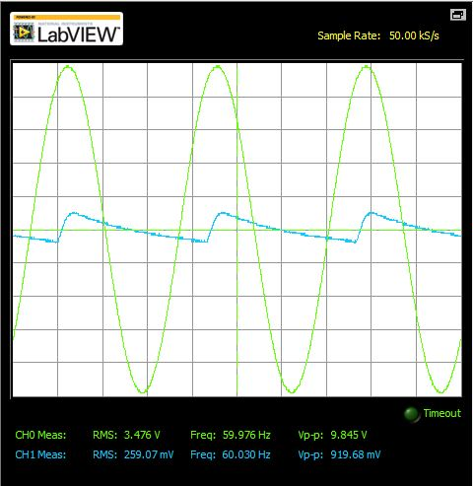

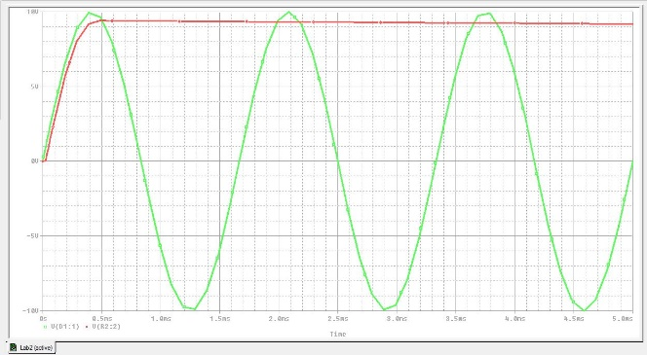Part B Diode-filtered rectifier circuit

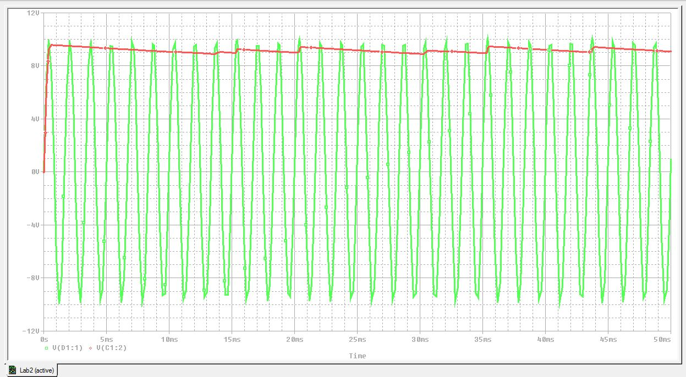Part B AM Diode-filtered rectifier circuit

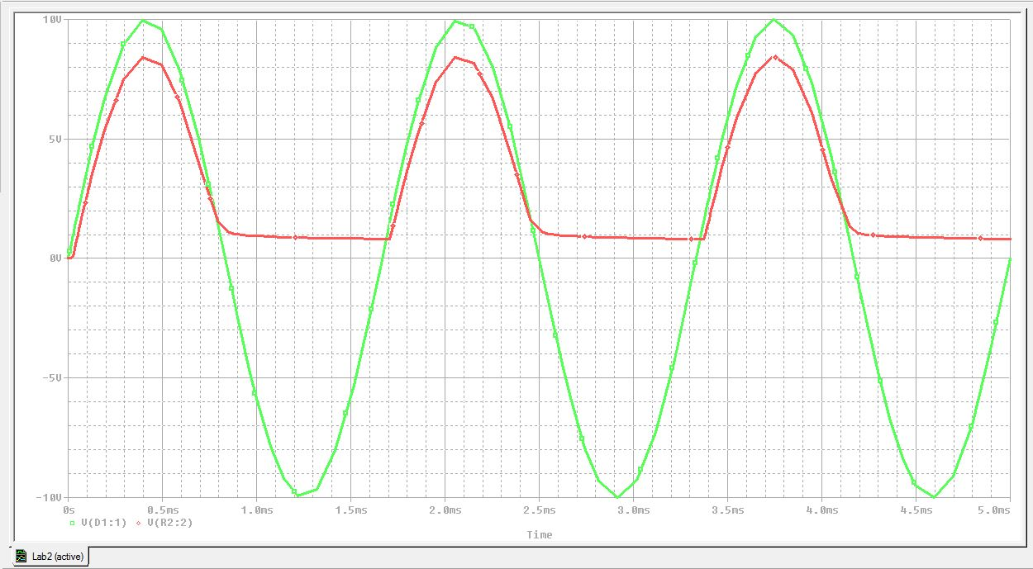Part B Zener Diode Circuit

Part B AM Zener Diode Circuit

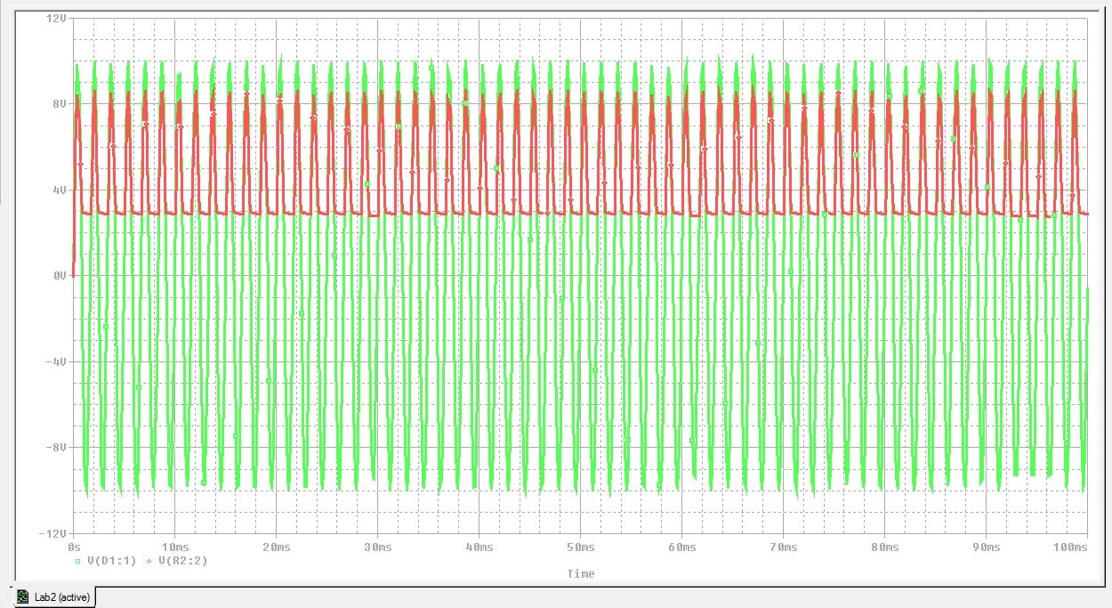

6.Calculations

Experimental Load Resistance

$R=\frac{V_{m}}{2fV_{r}C}$ $R=\frac{20}{2*60*0.1(22µF)}$ R= 75,757.57 ohms

Amplitude Modulation = $V_{m}[\sin\left(606t\right]+\sin\left(594\right)+V_{c}sin⁡(600)$– Using this function we implemented 3 AC sources it modulate the amplitude 